MINOR PROJECT VALIDATION FORM

Supervisor Name |  | Panel Head
 | DR. PRIYADHARSHINI K | DR. SOWMIYA B
 | Faculty Advisor | Project Domain
 | DR. PRIYADHARSHINI K | • Machine Learning  • Explainable AI (XAI)  • Smart Agriculture / Agri-Tech
M
 | Student(s) Details: Name | Passport size photo(s)
- RISHIKA DHANUKA

- VAIDEHI MISHRA

Registration Number(s)
1. RA2311003011165
2. RA2311003011168

Email ID(s)&Mobile Number(s)

1: rd0820@srmist.edu.in | +91 89867 63767
2: vm9115@srmist.edu.in | +91 925652 12257

1 | Abstract | The issue of food loss after harvest is also a significant problem in the agricultural supply chain, especially in the developing economies where poor storage facilities and environmental variations influence the quality of produce. Most of the fresh produce spoils during storage and transportation because of the change in temperatures, humidity, exposure to light, and lack of monitoring systems. The conventional methods of post-harvest management are mostly based on manual checks and the defined storage procedures that cannot work effectively in terms of identifying the spoilage risks at an earlier stage. This paper suggests CropSight, a risk scoring model that explains machine learning-based risks of predicting post-harvest produce spoilage through a combination of environmental and produce-related factors. The model proposed is based on the use of such features as temperature, humidity, light exposure, carbon dioxide concentration, and fruit type to approximate the quality of the storage conditions. Three machine learning models were applied and compared, namely, Logistic Regression, Random Forest, and Gradient Boosting. As shown in experimental findings, the highest predictive accuracy of 99.86% was in the case of Random Forest, which is preceded by 99.73% in the case of Gradient Boosting. A 5-fold cross-validation plan yielded a mean accuracy of 97.10% with the help of the Random Forest model.  To facilitate interpretability, SHAP (SHapley Additive exPlanations) analysis was used in order to determine the environmental factors that have the highest contribution to the prediction of the spoilage risk. The forecasted probabilities were then converted to a continuous risk measure to facilitate proactive decision making in the post harvest storage management.
2 | RESEARCH GAP  (not more than 3 points) | - Existing systems rely on threshold-based monitoring, not predictive modelling  - Lack of explainable AI integration in agricultural storage systems  - Absence of actionable risk scoring frameworks for decision-making
3 | Please furnish the details of 5 research articles in IEEE Reference format with Impact factor and year of publication from Which Research gap has been identified (F. Lastname, “Title of article,” *Journal Name*, vol., no., pp., year. And IF 3.1)) / 5 Patent Details for highlighting the innovation | - L. Breiman, “Random forests,” Machine Learning, vol. 45, no. 1, pp. 5–32, 2001. (IF ~4.5)  - J. Friedman, “Greedy function approximation: A gradient boosting machine,” Annals of Statistics, 2001. (IF ~4.9)  - S. Lundberg and S.-I. Lee, “A unified approach to interpreting model predictions,” NeurIPS, 2017. (IF high)  - A. Kamilaris and F. Prenafeta-Boldú, “Deep learning in agriculture,” Computers and Electronics in Agriculture, 2018. (IF ~6.7)  - • L. Benos et al., “Machine learning in agriculture,” Sensors, 2021. (IF ~3.9)
4 | Bridging the Research Gap/ Innovation Gap  (not more than 3 points) | - Introduces predictive machine learning models for spoilage risk  - Integrates SHAP explainability for model transparency  - Develops a risk scoring system (0–100) for actionable insights
5 | OBJECTIVE  (not more than 5 points) | - Predict post-harvest spoilage risk using environmental data  - Compare multiple machine learning algorithms  - Identify key spoilage factors using explainable AI (SHAP)  - Develop a continuous risk scoring mechanism  - Support proactive decision-making in storage systems
6 | System Architecture | 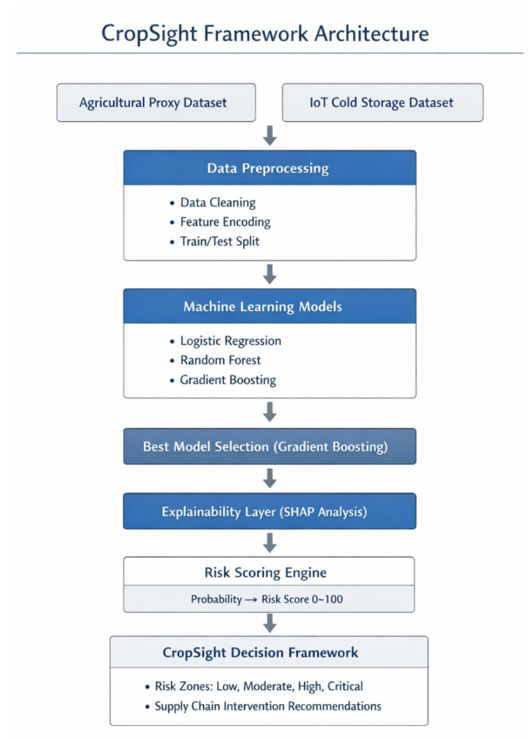  FLOW:-  Dataset → Preprocessing → ML Models → Best Model (RF)  → SHAP Explainability → Risk Scoring → Decision Framework
7 | METHODOLOGY  (not more than 10 points) | - Dataset collection (environmental storage data)  - Data cleaning and preprocessing  - Feature selection (Temp, Humidity, Light, CO₂, Fruit)  - One-hot encoding for categorical variables  - Train-test split (80:20)  - Model training (LR, RF, GB)  - Model evaluation (Accuracy, Precision, Recall, F1)  - 5-fold cross-validation  - SHAP explainability analysis  - Risk score generation (0–100 scale)
8 | OUTCOMES OR DELIVERABLES  (not more than 5 points) | - Trained machine learning model  - Explainability analysis using SHAP  - Risk scoring system  - Performance evaluation report  - Research paper (IEEE format)
9 | NOVELTY  (not more than 3 points) | - Integration of ML + Explainable AI + Risk Scoring  - Conversion of predictions into actionable risk levels  - Transparent decision-support framework for storage systems
10 | Time line | Deliverables
 | November 2025(Review 0) | Problem identification + literature survey
 | January 2026 (SPRINT Review 1) | Dataset + initial model development
 | March 2026 (SPRINT Review 2) | Model optimization + explainability
 | April 2026 (SPRINT Review 3) | Final system + paper submission
11 | Collaboration details | - Internal team collaboration  - Guidance from faculty supervisor
12 | Target Technology Readiness Level of the project  (TRL Scale 1 to 9)  TRL 1 -Basic principles observed and reported.  TRL 2 -Technology concept formulated.  TRL 3 -Experimental proof of concept.  TRL 4- Technology validated in lab.  TRL 5- Technology validated in a relevant environment.  TRL 6 -Technology demonstrated in a relevant environment.  TRL 7- System prototype demonstration in operational environment.  TRL 8- System complete and qualified.  TRL 9- Actual system proven in operational environment. | TRL 4 – Technology validated in lab
13 | Sustainable Development Goal (1-17) ( Most prominent one goal) | SDG 2 – Zero Hunger
14 | Industry Practice followed for system development ( Agile- SCRUM) | Agile – SCRUM methodology  - Sprint planning  - Daily standups  - Iterative model improvement

Conference/Journal Publication/Patent Details (Mandatory, Target Publication a)
IEEE Conference / Scopus-indexed Journal

Signature of Students: 1.

2.

Signature of the Supervisor:

